# CS 255 System Design Document Template

This template lays out all the different sections that you need to complete for Project Two. Each section has guidance to prompt your thinking. You will need to continually reference the interview transcript as you work to make sure that you are addressing your client’s needs. There is no required length for the final document. Instead the goal is to complete each section based on what your client’s needs are. Remove this note when you are finished, and replace all bracketed text with the relevant information.

## UML Diagrams

### UML Use Case Diagram

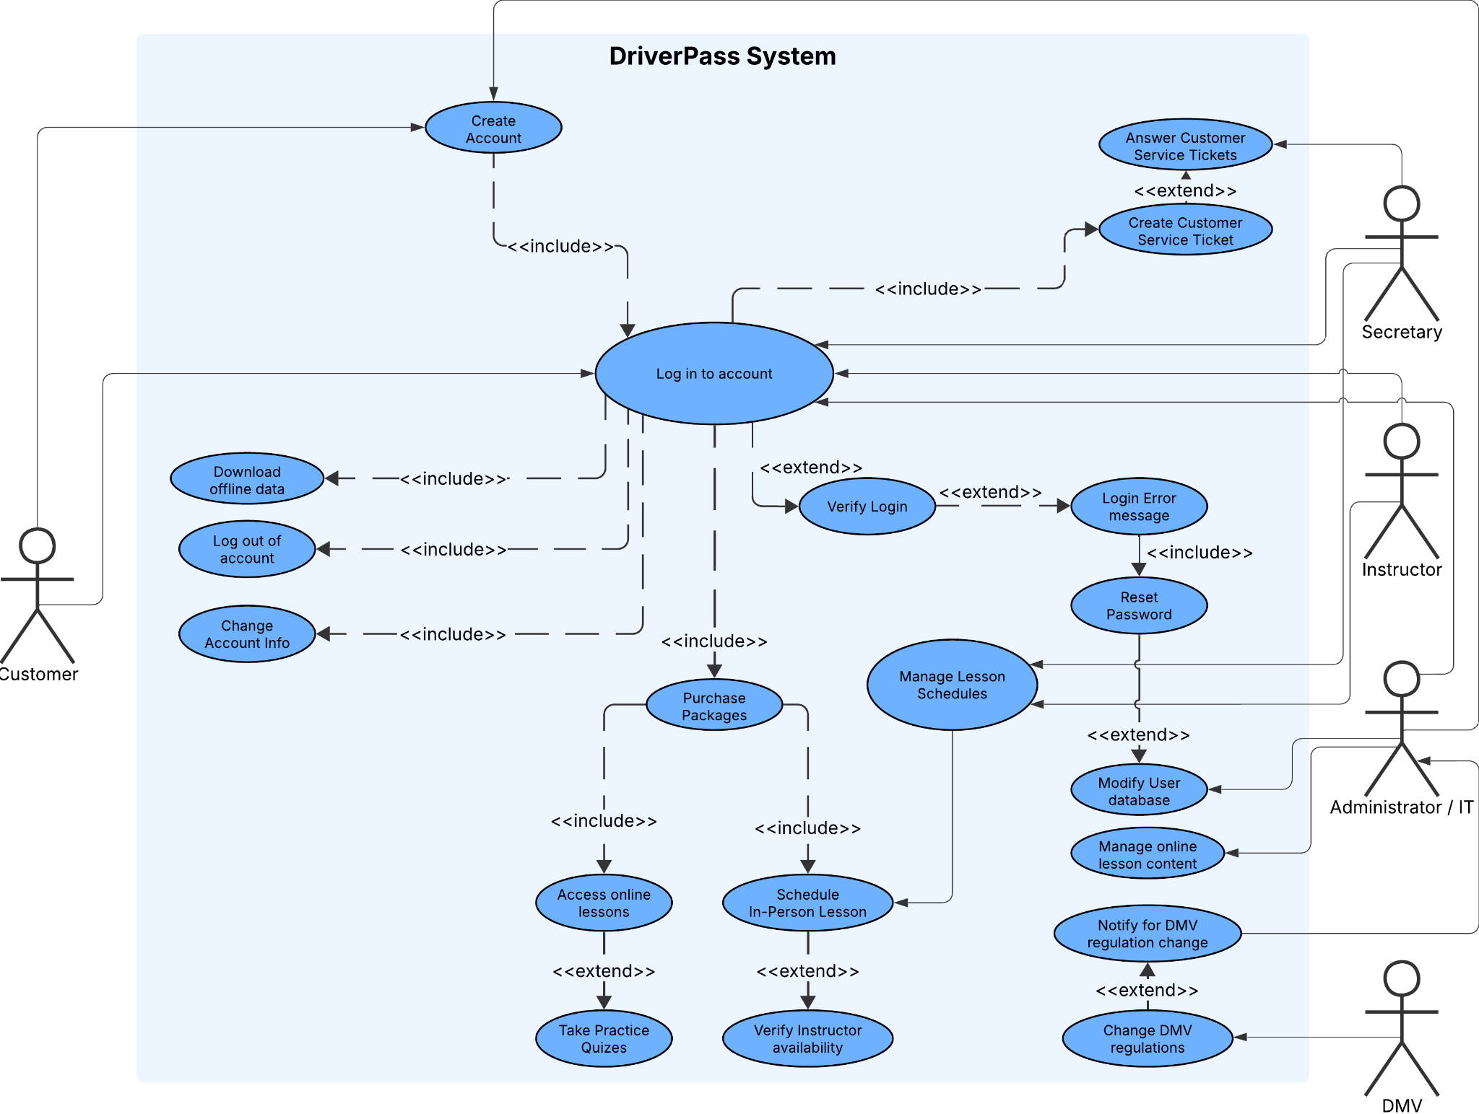

### UML Activity Diagrams

### UML Sequence Diagram

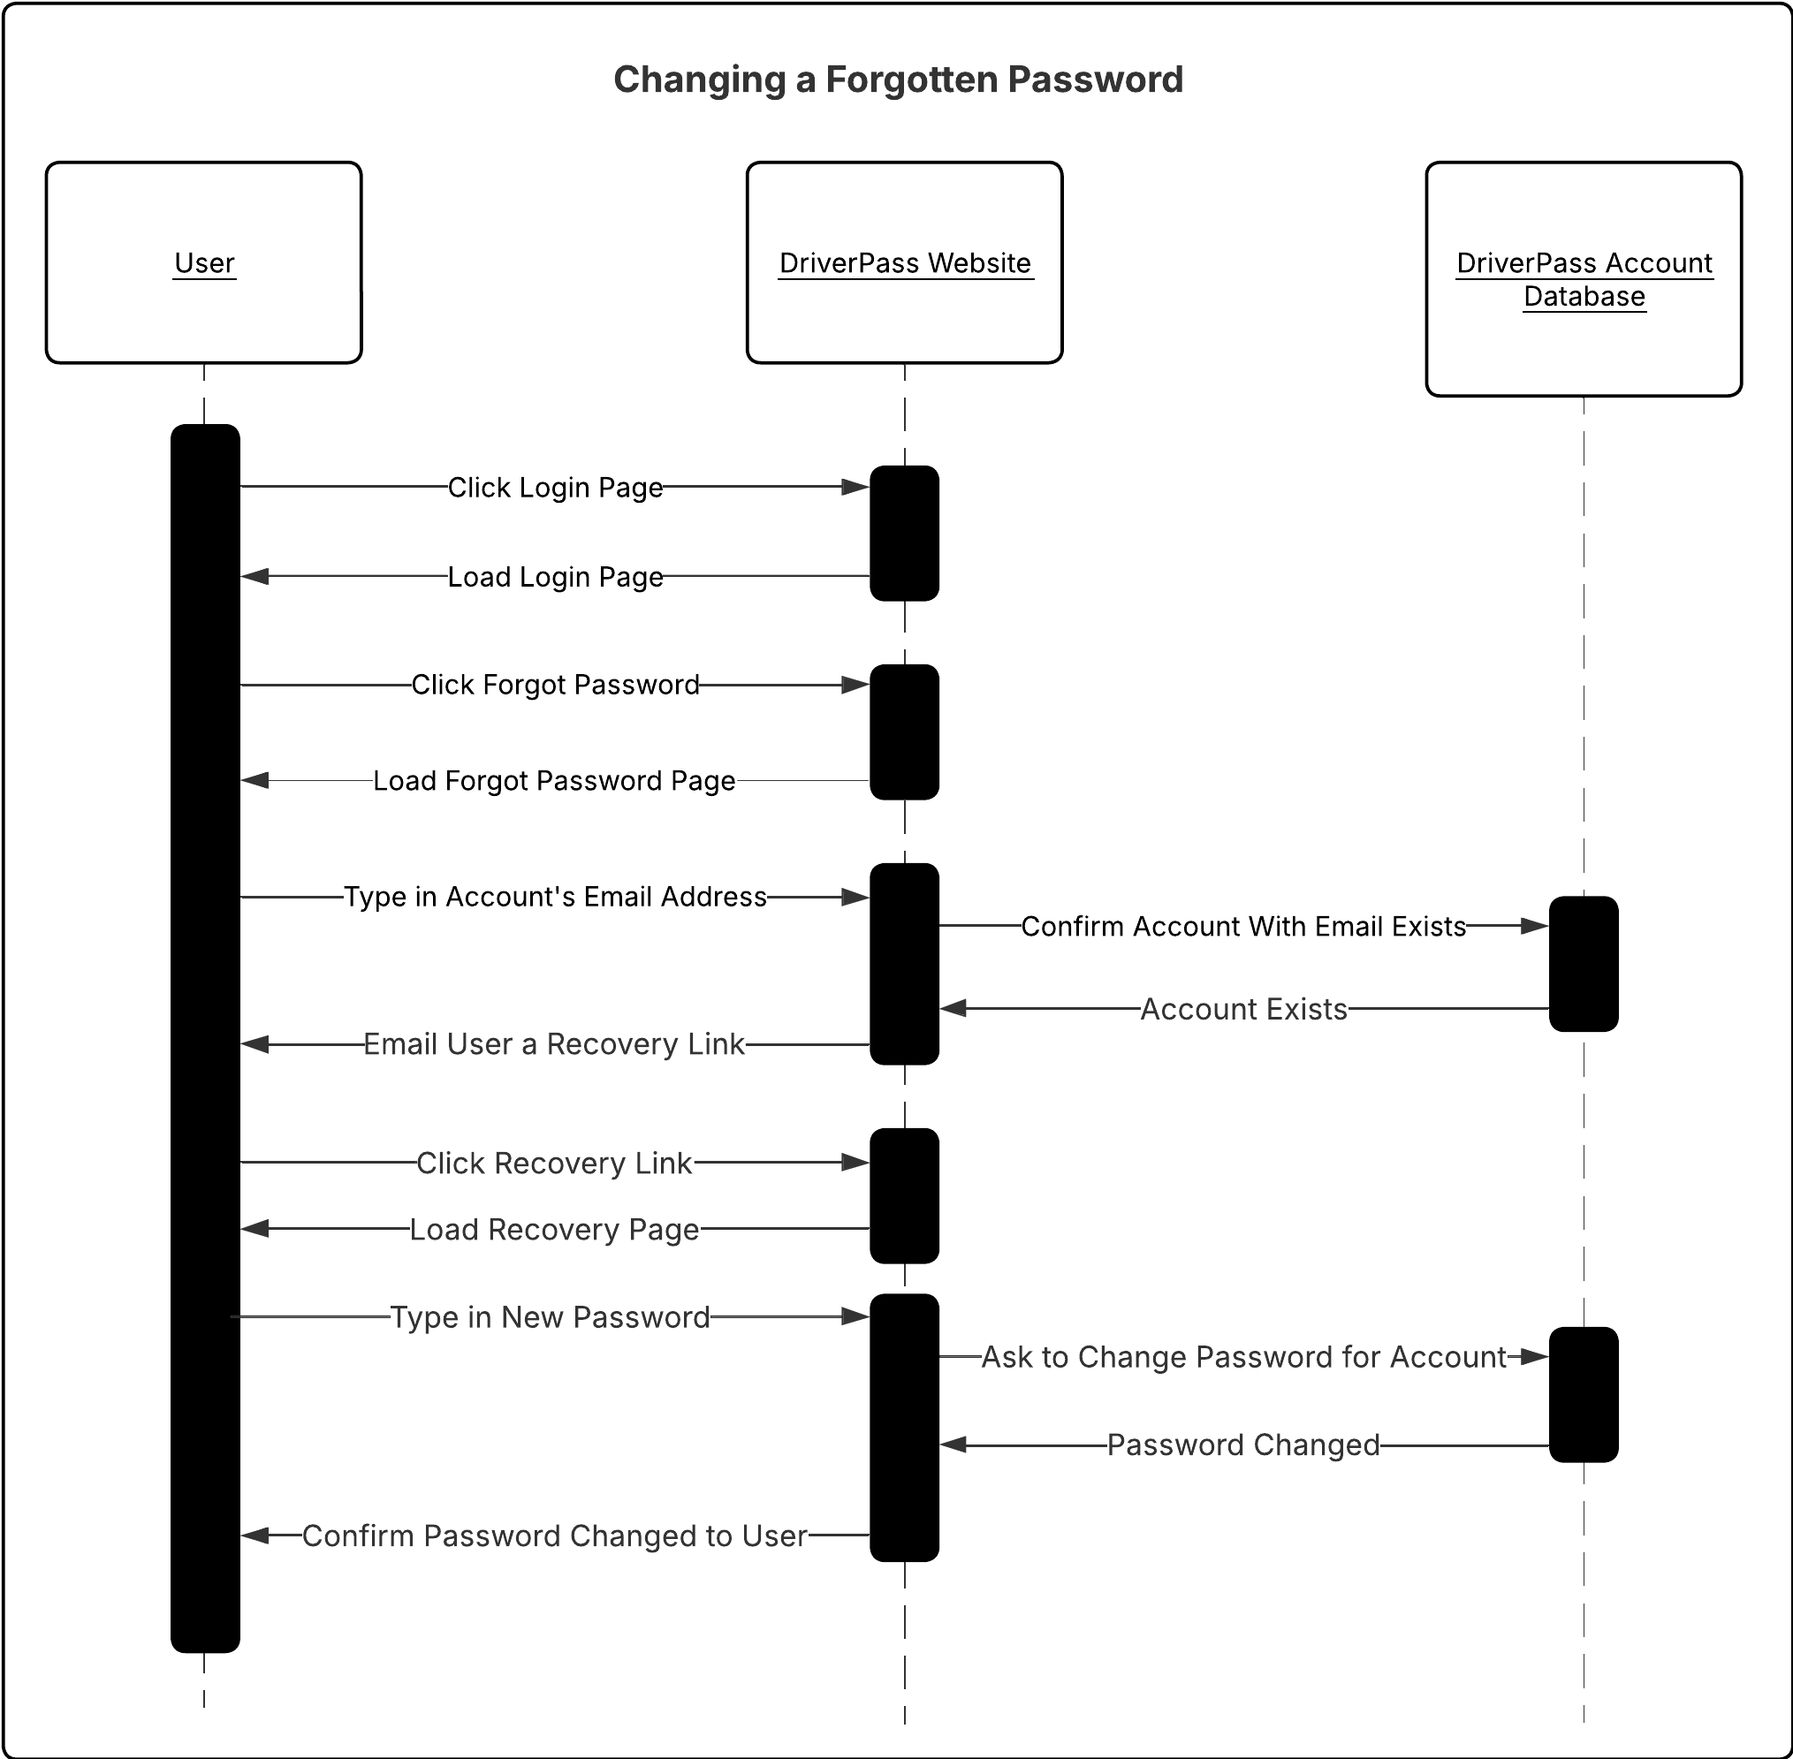

### UML Class Diagram

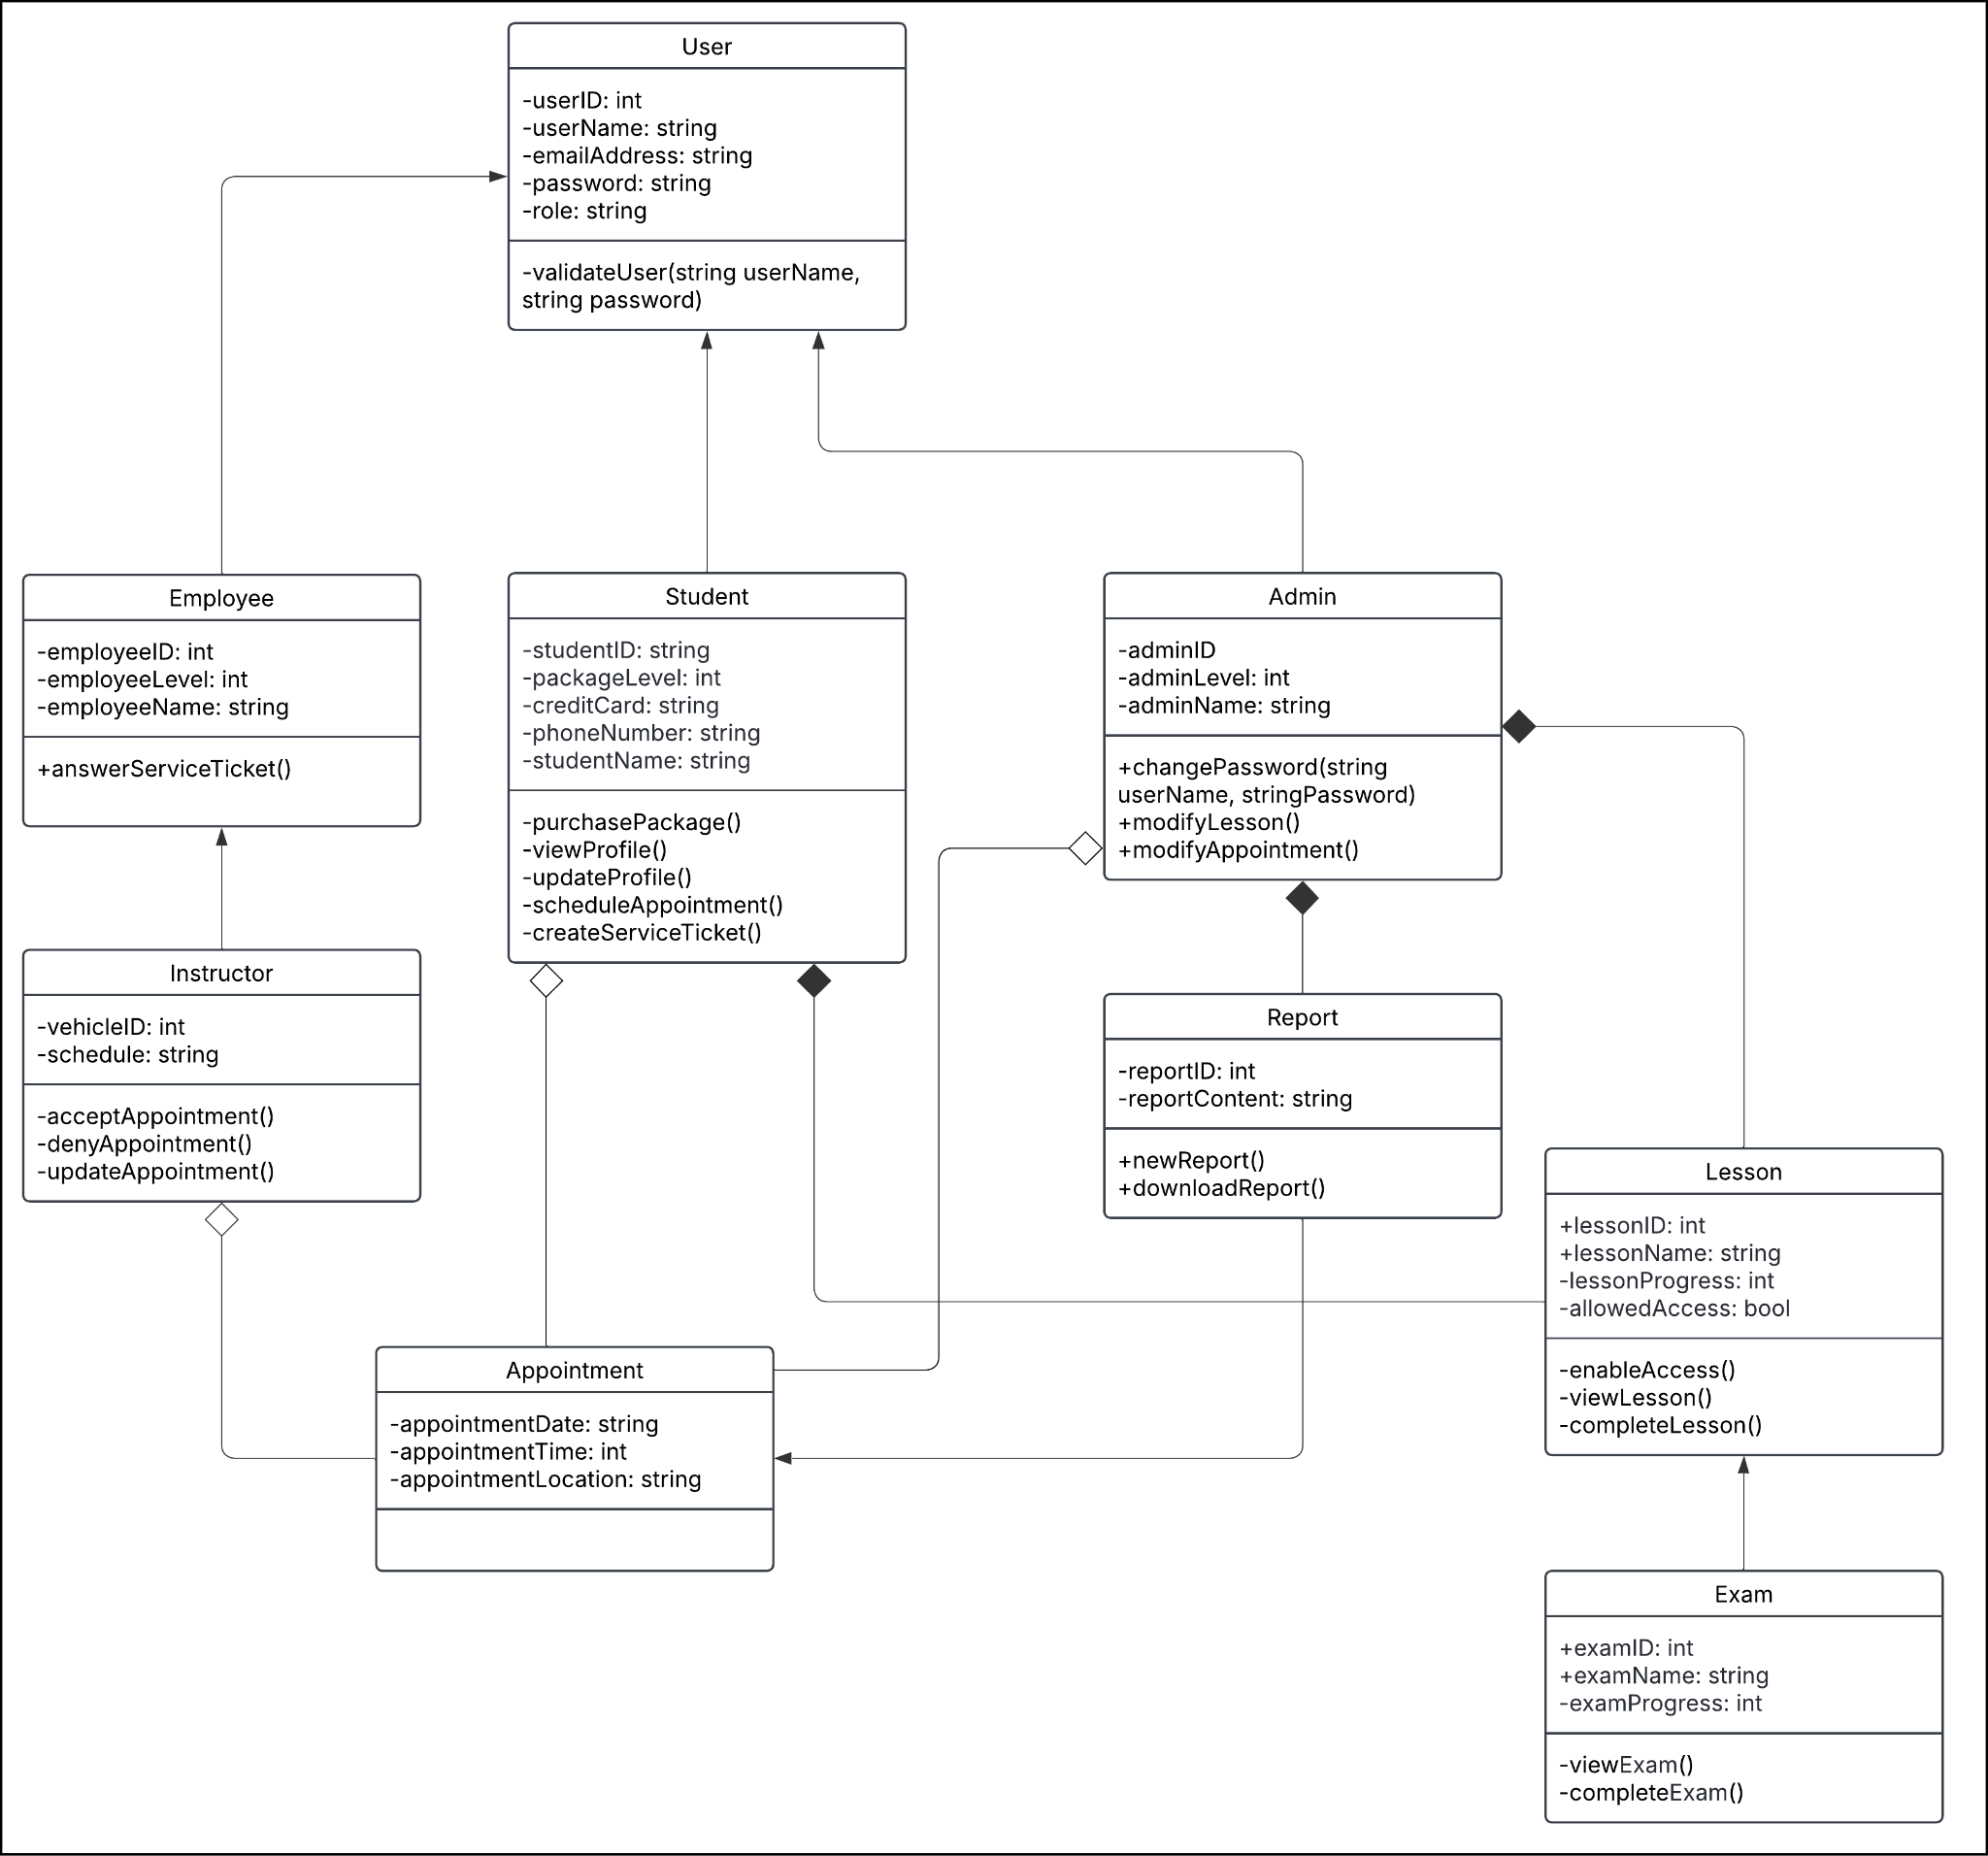

## Technical Requirements

**User Requirements:**

Hardware Requirements:

* Any device that can access the internet through a browser, such as a computer, or cell phone.
* Internet connection, either through a router or cellular data
* Storage space to download reports and schedules for offline use

Software Requirements:

* Any operating system that can access an internet browser.
* Access to the DriverPass Website

**Server Requirements:**

Server Infrastructure:

* Cloud Hosting, provided by a cloud provider such as AWS
* Computer for IT and the Administrators to access the cloud server.
* Database for user information and appointments, as well as the ability to download this database locally.
* Admin permission settings and an Admin portal for accessing the database via a user interface.

Required Tools:

* Software development IDE (Visual Studio for C++ and python code, Eclipse for Java)
* Internet connection for connecting to the site and modifying it.